CHAPTER 4

GAYATIN DENTAL CLINIC ONLINE APPOINTMENT AND PATIENT PROFILING SYSTEM SOFTWARE DEVELOPMENT

This chapter focuses on the different process flows of the system, its interfaces, user characteristics, database relationships, specific requirements, system requirements, constraints, and its assumptions and dependencies in developing the Gayatin Dental Clinic Online Appointment and Patient Profiling System.

## 4.1 Requirement Specification

### 4.1.1 Business Process Flow

**Figure 4.1** shows the current business process of Gayatin Dental Clinic. The clinic caters patients with appointments and walk-in patients. Once a patient visits the clinic, it's checked whether he/she is a new patient or not. If not then the staff looks for that patient's profile. If the patient is new, a patient profile is created. After that, the dentist performs the services, records the services rendered then the staff calculates the total bill, produces an official receipt then the patient pays. On the appointment part, the patient contacts the clinic and tries to create an appointment. The staff then determines if they will be open on that day. If it's open then the patient will be added to the list of people who will be having an appointment for that schedule. If not then the staff informs the patient then he/she has the option to choose another schedule or not.

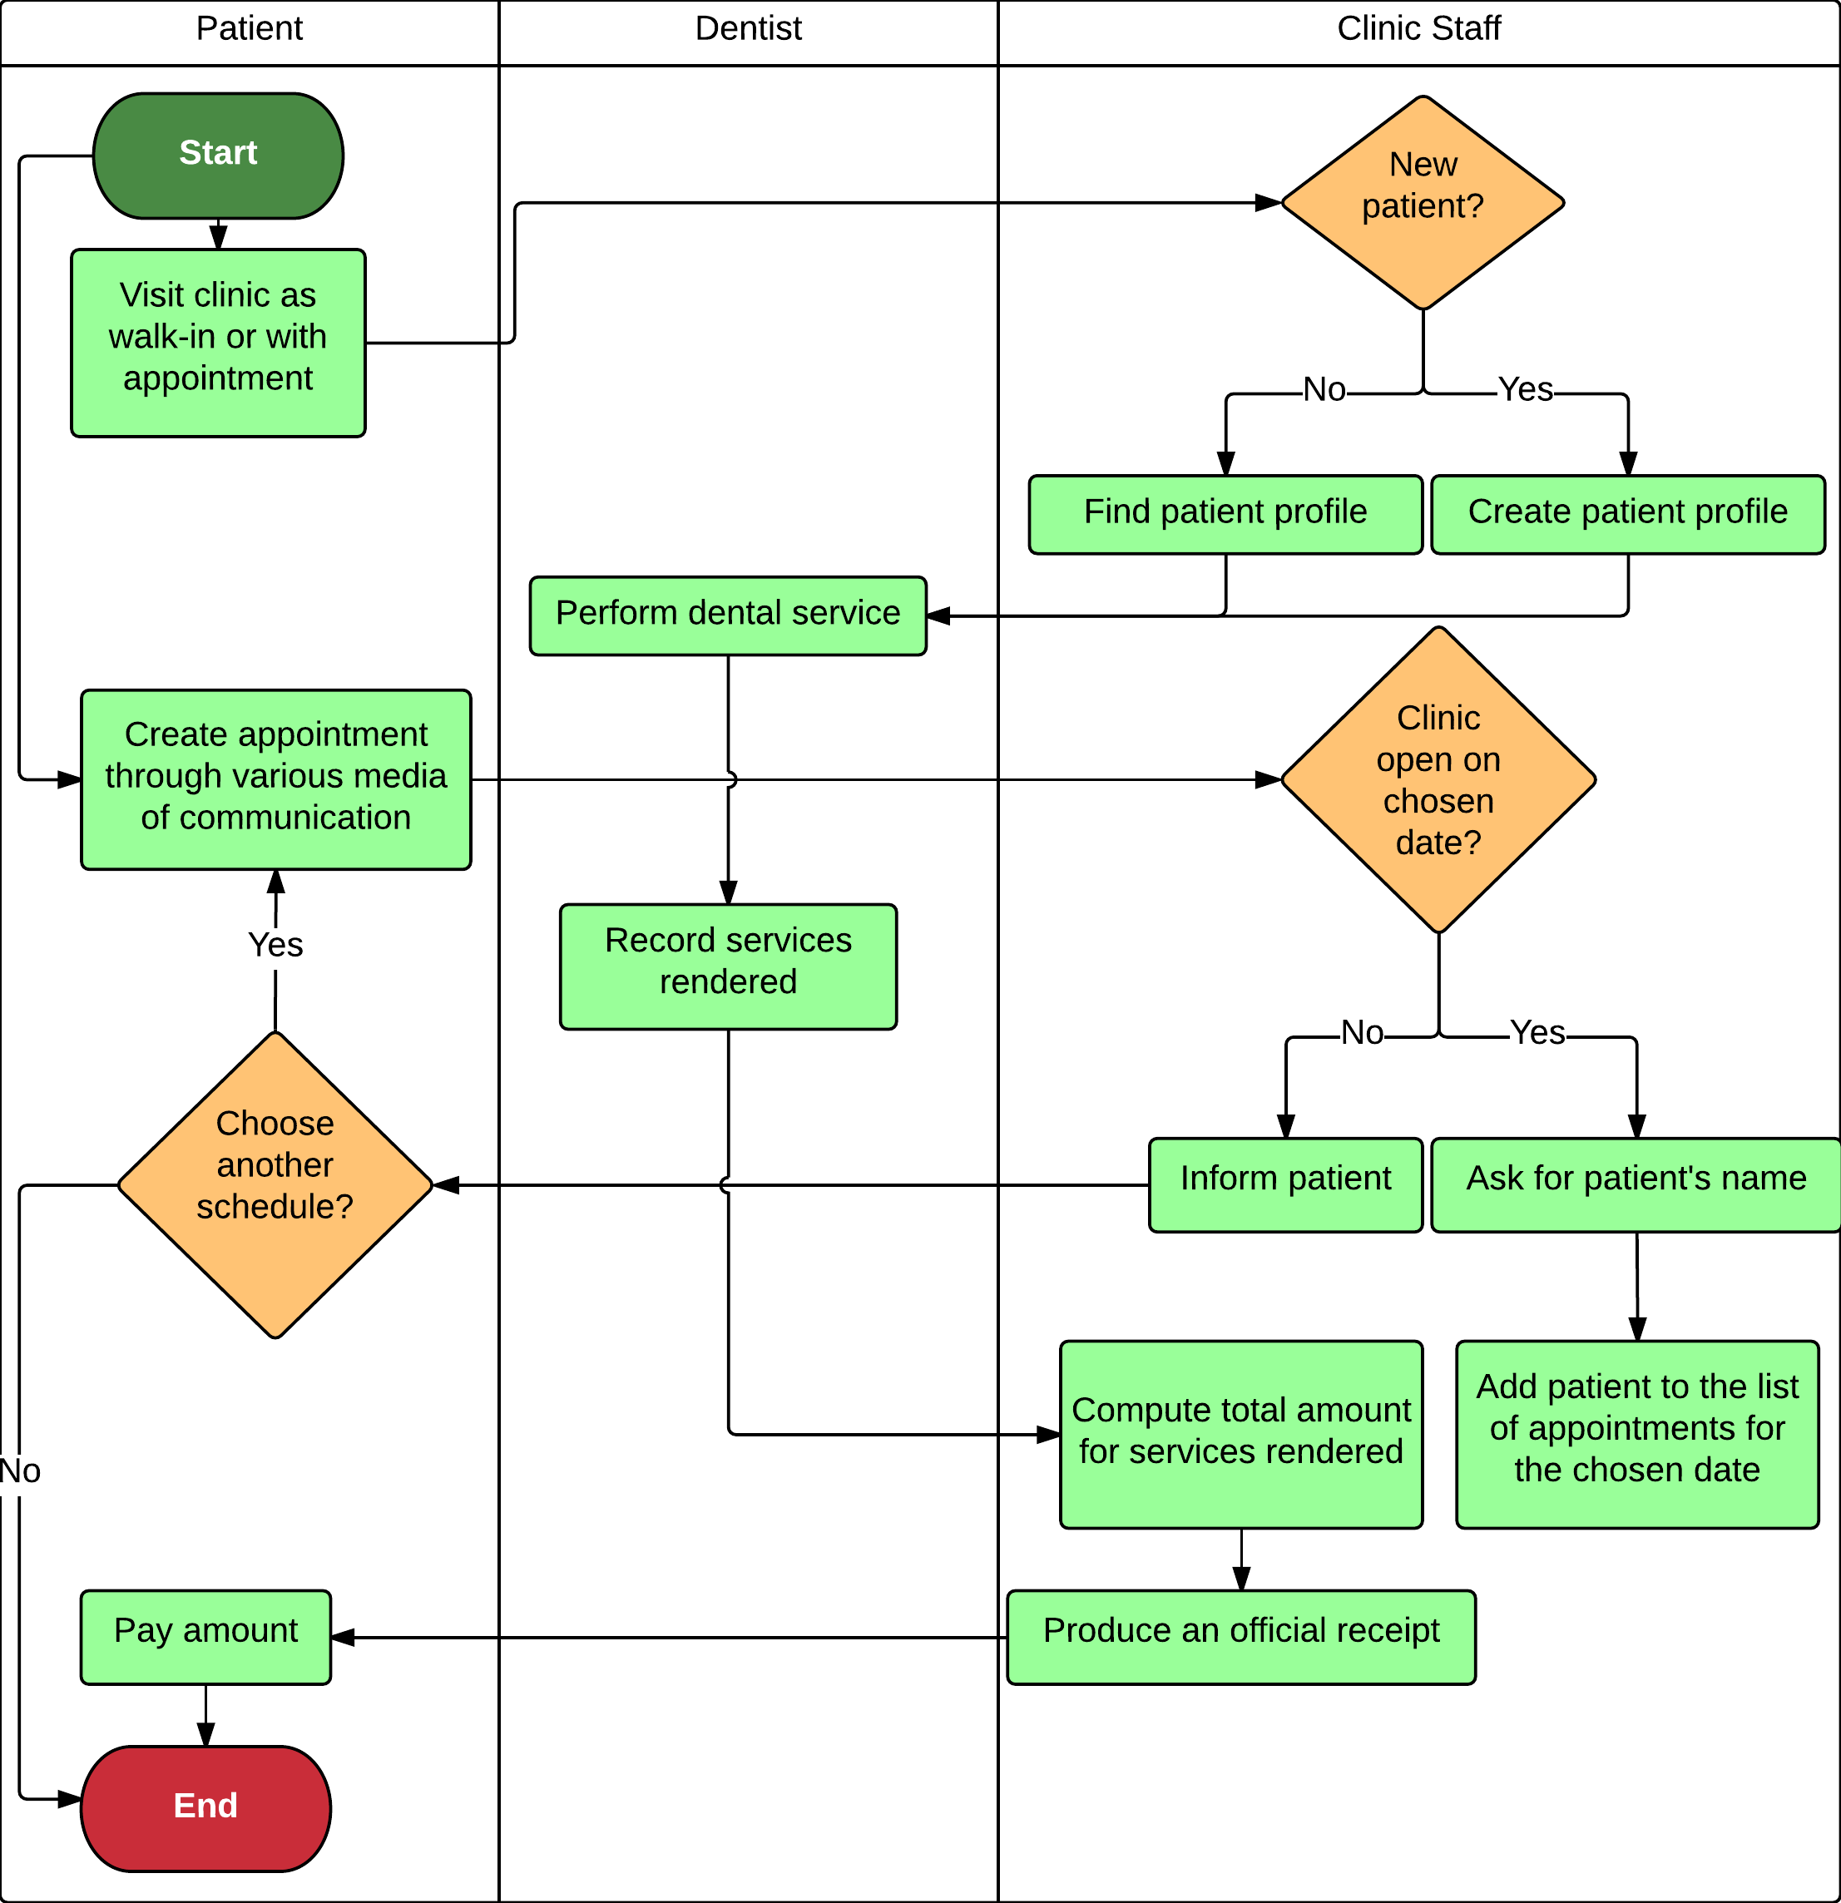

Figure 4.1 Gayatin Dental Clinic Business Process Flow

### 4.1.2 System Process Flow

**Figure 4.2** shows the system process flow for a guest user. Upon entering the website, the user can either view the homepage, view the about us page, or view the clinic calendar. Upon viewing the clinic's calendar, the user can then create an appointment for a chosen schedule.

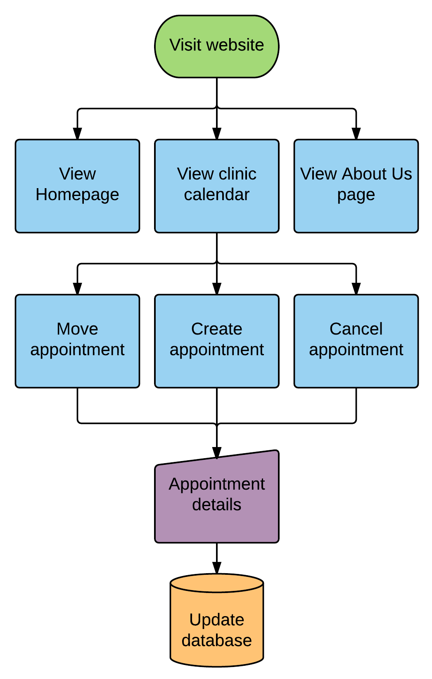

Figure 4.2 Guest User Flow

**Figures 4.3 and 4.4** show the system process flow for an admin user. An admin user could either be a clinic staff or a dentist. An admin user has multiple functionalities which he/she can perform upon logging-in. Upon viewing the clinic calendar, an admin can choose to close or open a schedule for appointments, or create an appointment. An admin may view the list of pending appointments and could choose to either confirm, cancel, or move a pending appointment. An admin may also view the list of confirmed appointments and could choose to accept, cancel, or move a confirmed appointment. An admin has the capability to generate reports, manage patient profiles, manage the dental services, and change the password for his/her account. Only the dentist users have the privilege to manage the user accounts of the system.

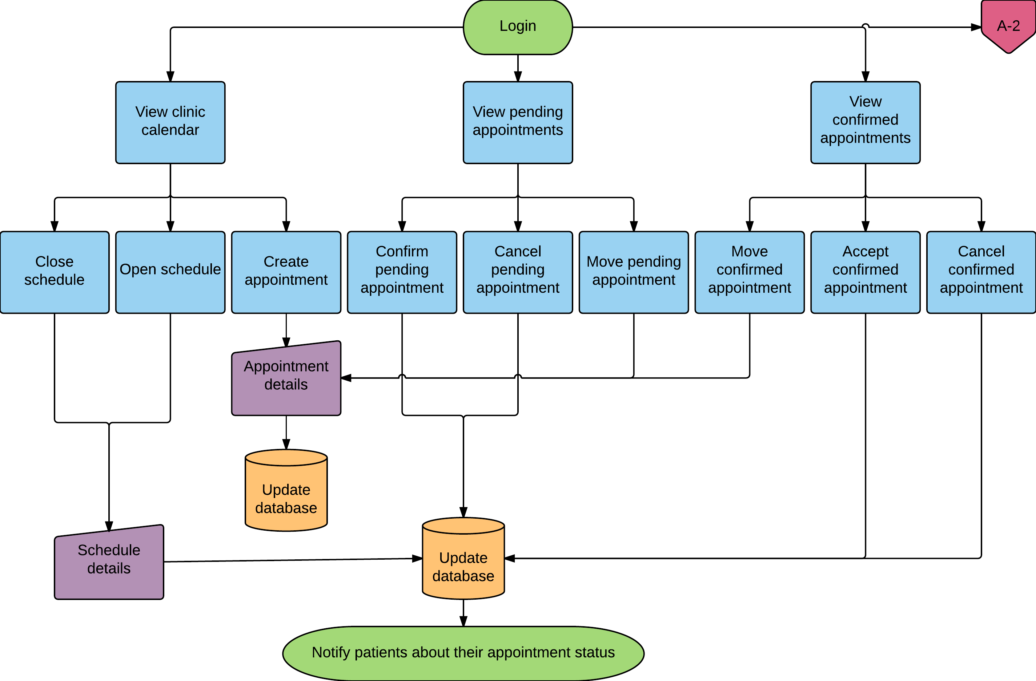

Figure 4.3 Admin User Flow

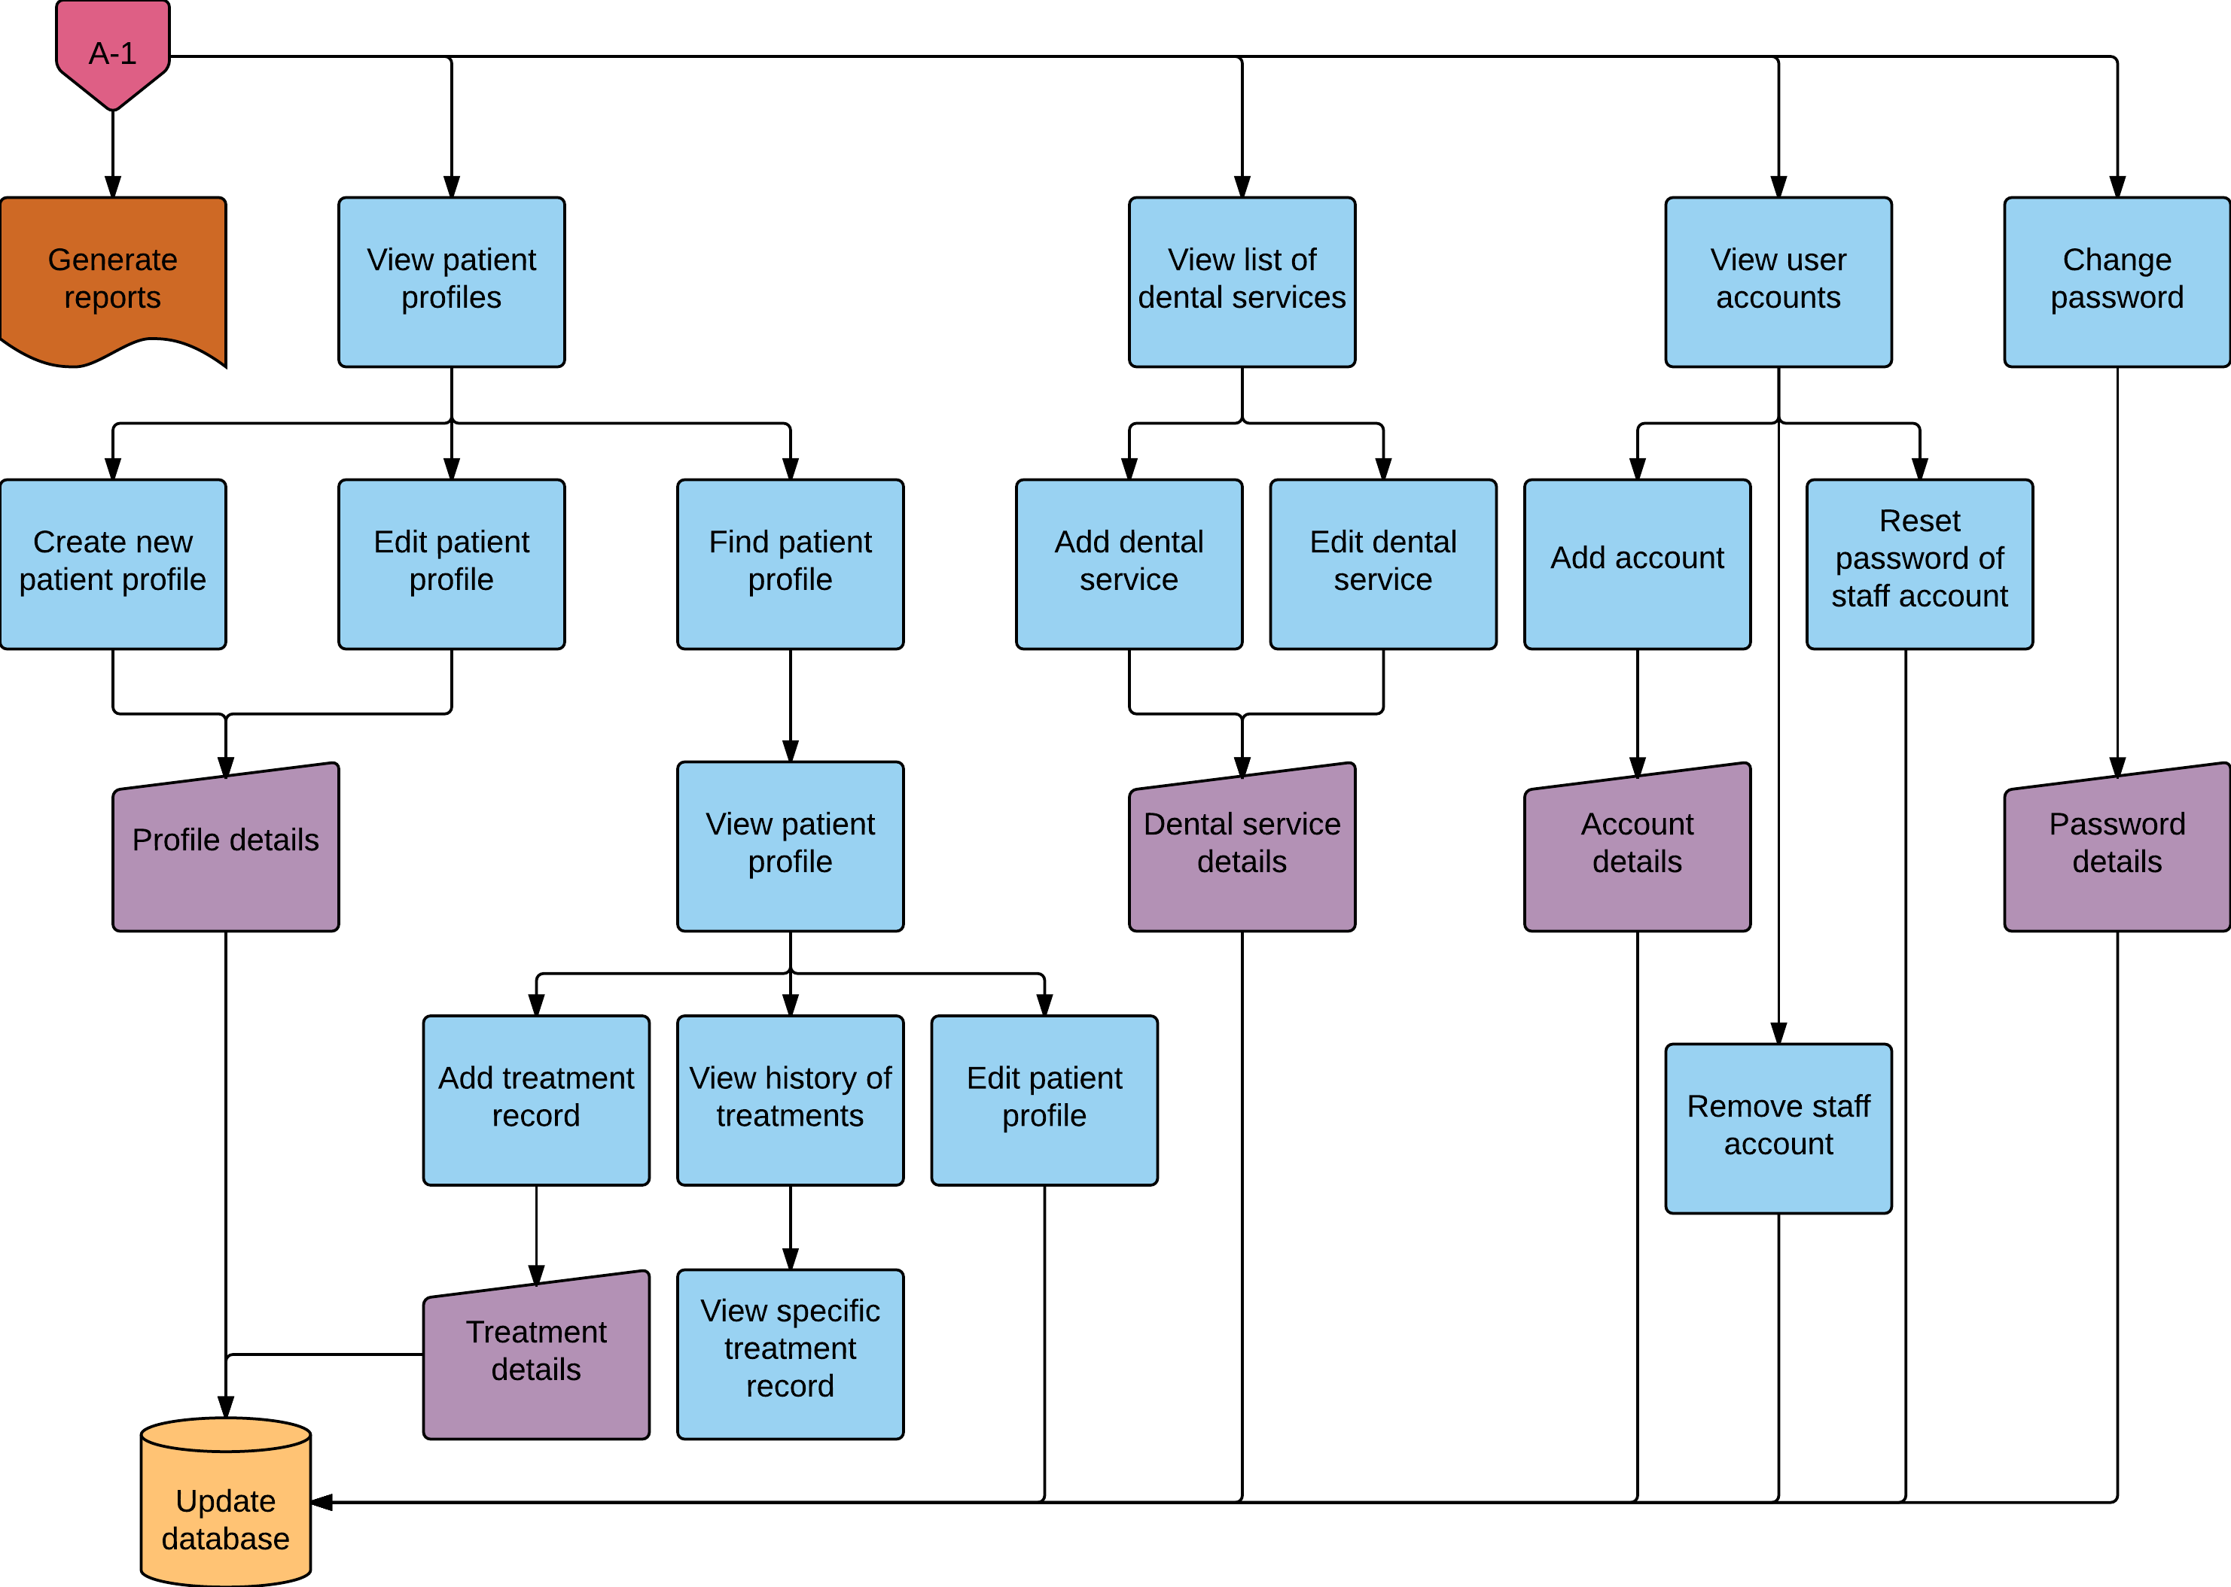

Figure 4.4 Admin User Flow – continued

### System Interfaces

**Report Generator Module**

This module allows the clinic or admin to generate 4 kinds of reports. The first is the List of Clients per Month which allowed the generation of the list of new patients on a chosen month. The second is the Gender and Age Classification of Patients which allowed the generation of the different age and gender classifications of patients on a chosen timespan. The third is the List of Services Rendered which allowed the generation of the list of services availed by patients along with its frequency on a chosen timespan. The fourth is the Appointment Status which allowed the generation of the number of created, confirmed, and cancelled appointments on a chosen timespan.

**Patient Management Module**

This module allows the clinic staff or admin user to electronically create patient profiles and update them accordingly. The user may also view the list of patient profiles, find a patient profile, and view a specific patient profile.

**Transactions Management Module**

This module allows the clinic staff or admin user to add an appointment record to a patient profile. The user may also view the history of appointments of a patient, view a specific appointment record, and print an appointment record.

**Teeth Profile Management Module**

This module allows the clinic staff or admin user to create a teeth profile for a new patient and update the teeth profile of an existing patient. The user may also view the history of the teeth profile and view the teeth profile on a specific date.

**Appointment Management Module**

This module allows a guest, clinic staff, or admin user to create appointment reservations on specific timeslots. It could also allow the clinic staff or admin to track manage the upcoming and pending appointments and they also have the ability to accept or remove a pending or an upcoming appointment. This module is also responsible for sending SMS and email notifications to patients with regard to the status of their appointment reservation.

**Clinic Schedule Management Module**

This module allows a clinic staff or admin user to view the clinic calendar and set a specific date on the calendar to be open or closed for patient appointments.

**Account Management Module**

This module allows an admin user to add a new account for a clinic staff or a dentist, view the list of accounts, reset a staff account password, and remove a staff account. The clinic staff or admin user may also change their respective passwords.

**Clinic Services Management Module**

This module allows the clinic staff or admin user to view the list of dental services, add a dental service, update dental services information, and remove a dental service.

### home - guestUser Interfaces

Figure 4.5 Landing Page for Guest User

**Landing Page for Guest User**

(Fig. 4.5) This is the page that guest users will see upon entering the site. The page contains information about Gayatin Dental Clinic.

Figure 4.6 Appointment Reservation View – without data input

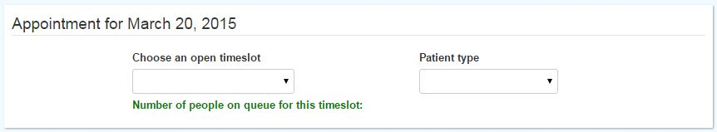

**Appointment Reservation View**

(Fig. 4.6) This is where the user will be redirected after selecting a date on the Clinic Calendar.

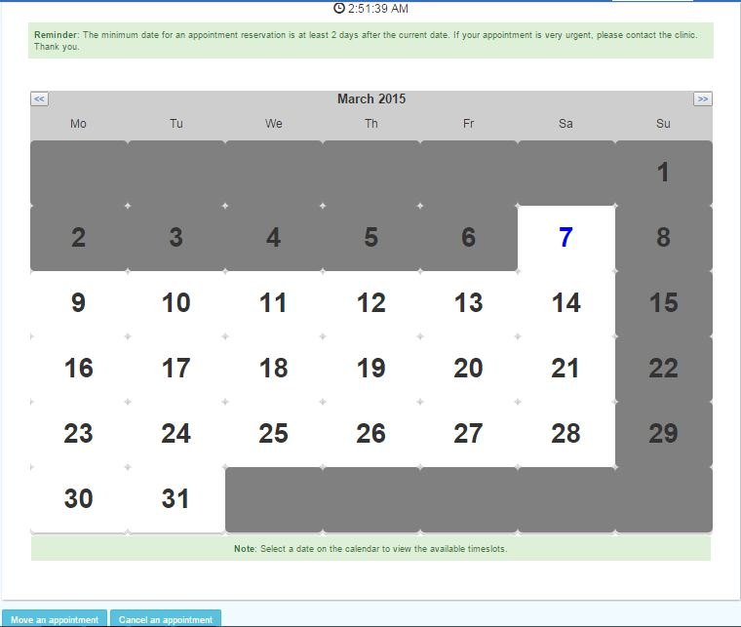Figure 4.7 Clinic Calendar Page

**Clinic Calendar Page - Guest User**

(Fig. 4.7) The user will see the available schedules for appointment of the clinic on this page. When a user selects a date, the user will be redirected to the Appointment Reservation page. The user also has the option to cancel a previously made appointment reservation on this page.

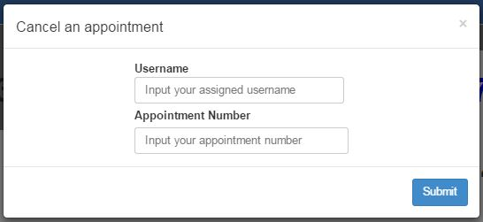Cancel an Appointment

Figure 4.8 Cancel an Appointment

(Fig. 4.8) This allows the user to cancel a previously made appointment reservation. The user needs to input his/her username and the date which he/she wants to cancel a reservation.

Figure 4.9 Landing Page for Clinic Staff and Admin

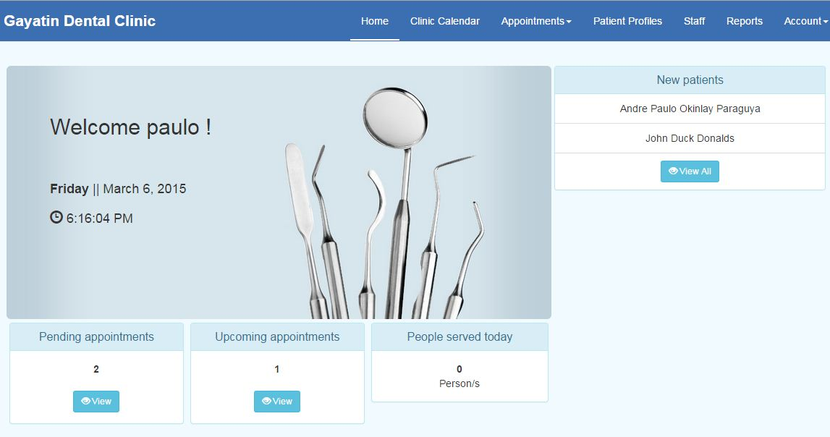**Landing Page for Clinic Staff and Admin**

(Fig. 4.9) This is what the clinic staff or admin users see after successfully logging in.

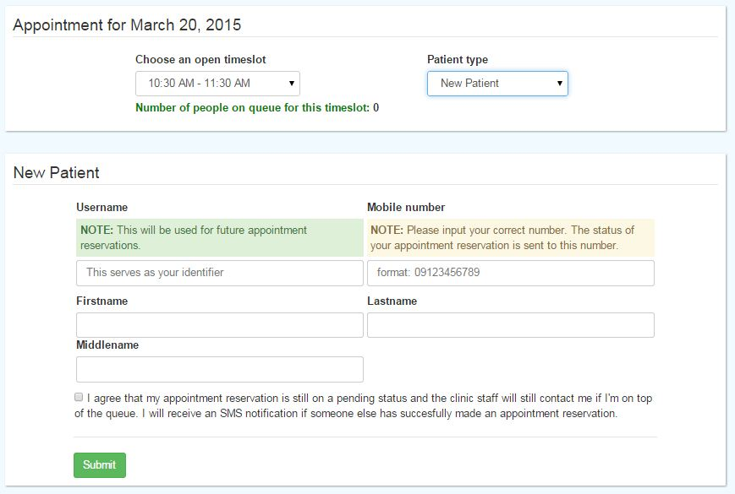**Appointment Reservation View – New Patient**

Figure 4.10 Appointment Reservation View – New Patient

(Fig. 4.10) After selecting a new patient as the patient type on the empty Appointment Reservation View, the form for a new patient reservation will be appended.

**Appointment Reservation View – Old Patient**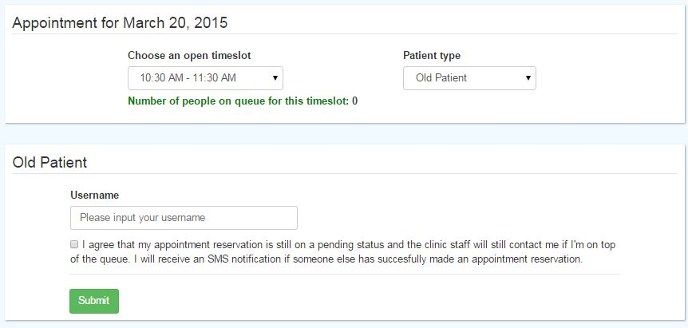

Figure 4.11 Appointment Reservation View – Old Patient

(Fig. 4.11) After selecting an old patient as the patient type on the empty Appointment Reservation View, the form for an old patient reservation will be appended.

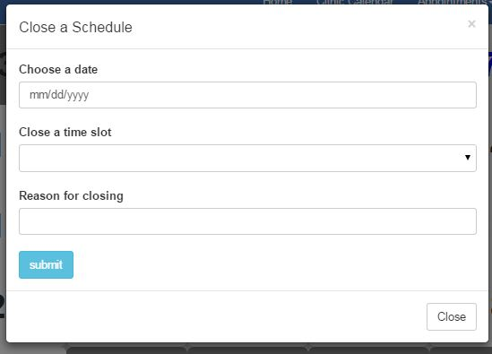Close a Schedule – Clinic Staff or Admin User

Figure 4.15 Close a Schedule – Clinic Staff or Admin User

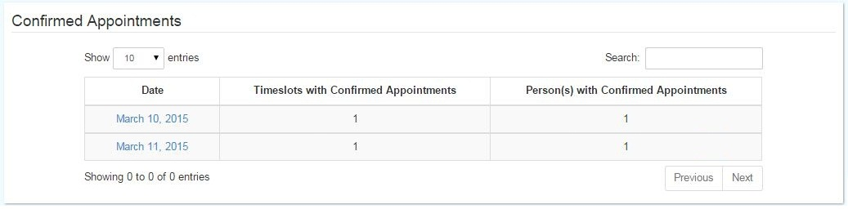(Fig.4.15) This is where the clinic staff or admin choose a date to be closed

Figure 4.16 Upcoming Appointments – List of Dates

Upcoming Appointments – List of Dates

(Fig. 4.16) This page contains the list of dates which have upcoming appointments.

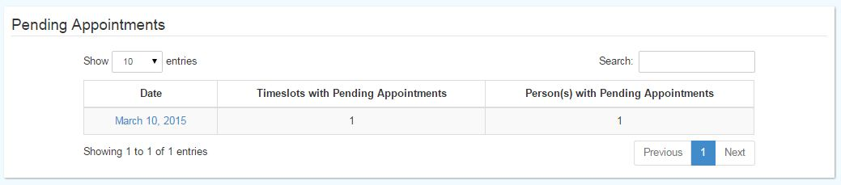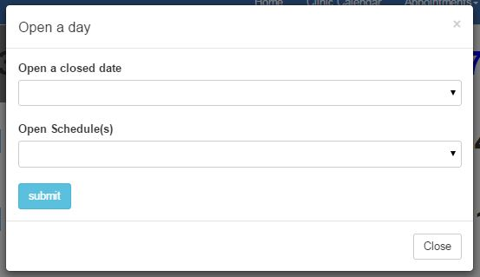Open a Schedule – Clinic Staff or Admin User

Figure 4.17 Open a Schedule – Clinic Staff or Admin User

(Fig. 4.17) This is where the clinic staff r admin selects a date to be opened for appointments from the list of closed dates.

Figure 4.18 Pending Appointments - List of Dates

**Pending Appointments - List of Dates**

(Fig. 4.18) This page contains the list of dates which have pending appointment reservations.

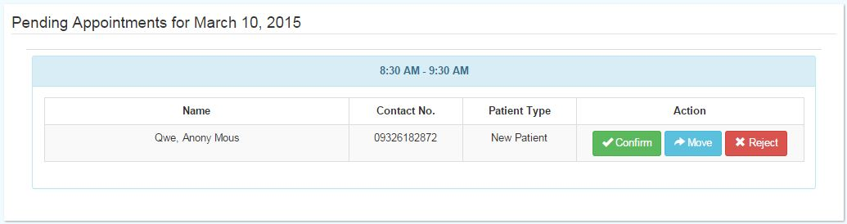**Pending Appointment Reservations for a Specific Date**

Figure 4.19 Pending Appointment Reservation for a Specific Date

(Fig. 4.19) This page displays the timeslots for a specific date which have pending appointment reservations. The clinic staff or admin can either accept or remove a pending appointment reservation.

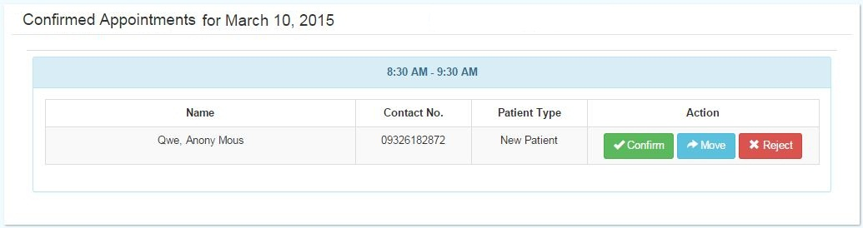

Figure 4.20 Upcoming Appointments for a Specific Date

**Upcoming Appointments for a Specific Da**t**e**

(Fig. 4.20) This page displays the timeslots for a specific date which have upcoming appointments. The clinic staff or admin can either accept or remove an upcoming appointment.

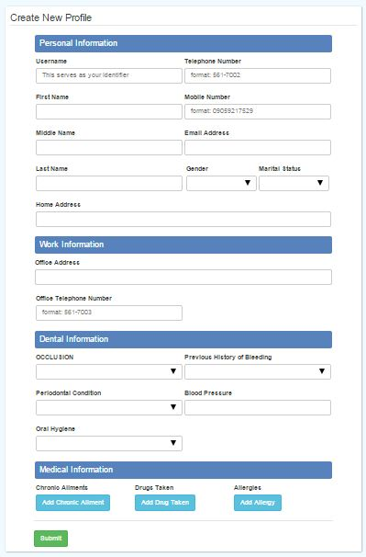

Figure 4.22 Create New Profile Page

**Create New Profile Page**

(Fig. 4.22) This is the page where a clinic staff or admin creates a new patient profile.

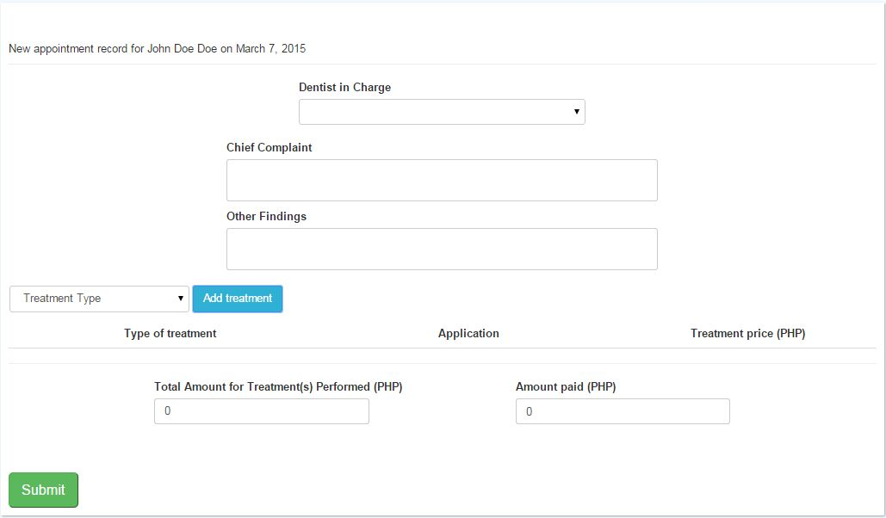

Figure 4.26 Adding of Appointment Record

**Adding of Appointment Record**

(Fig. 4.26) This is the page where the clinic staff or admin creates a new appointment record for a patient.

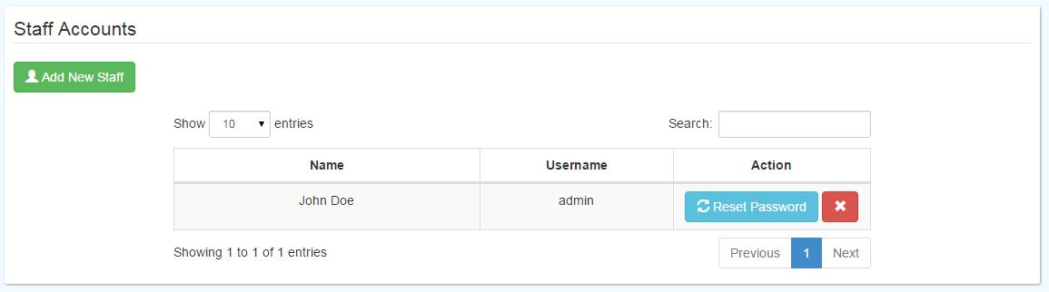

Figure 4.28 Staff

**Staff**

(Fig. 4.28) This page displays the list of clinic staff accounts on the system. Only the admin has access to this page. The admin has the option to add a new staff account, reset password for a staff, or remove a staff user.

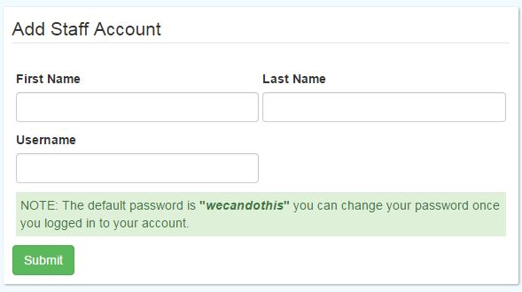

Figure 4.29 Add Staff Account

Add Staff Account

(Fig. 4.29) This is the page where the admin inputs the account information for the new staff.

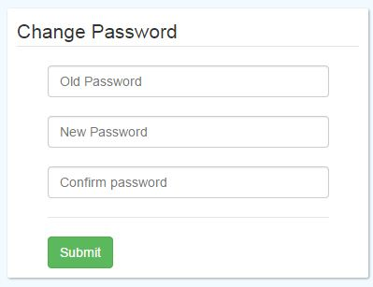

Figure 4.30 Change Password

**Change Password**

(Fig. 4.30) This is the view where an admin changes his/her current password to a new one.

### Hardware Interfaces

This section states the hardware aspect and interfaces that have been used throughout the development of the system.

**Laptops** were the primary tools used by the developers throughout the software development phase and the creation of documents which supported the system.

### Software Interfaces

This section states the software applications and software interfaces that were used throughout the development of the system.

**Git** is a [distributed revision control](http://en.wikipedia.org/wiki/Distributed_revision_control) system with an emphasis on speed, data integrity, and support for distributed, non-linear workflows.

**XAMPP** is a free and open source cross-platform web server solution stack package, consisting mainly of the Apache HTTP Server, MySQL database, and interpreters for scripts written in the PHP and Perl programming languages.

**Sublime Text** is a cross-platform text and source code editor, with a Python application programming interface (API). Sublime Text is proprietary software. Its functionality is extendable with plugins. Most of the extending packages have free-software licenses and are community-built and maintained.

**Bootstrap** is an open-source Javascript framework developed by the team at Twitter. It is a combination of HTML, CSS, and Javascript code designed to help build user interface components.

**Adobe Photoshop** is a raster graphics editor developed and published by Adobe Systems for Windows and OS X.

### Communication Interfaces

A **mobile pocket WiFi** was used to provide an internet connection in the dental clinic in order for the dentists and clinic staff to connect to the online server.

### 4.1.8 User Characteristics

The system’s users will include the patients of the clinic, the clinic staff, and the dentist in charge of the clinic.

**Guest.** A patient of the clinic or anyone who visits the website is considered by the system as a guest user. A guest does not need to login to the system. A guest can view the Homepage, Clinic Calendar page, and About Us page. The guest user can set an appointment without creating an account but the system will be acquiring relevant information from them.

**Administrators.** The clinic staff and the dentists are the administrators of the system. They need to login to the system in order for them to perform their functionalities. They are able to do a variety of things on the site. They could create, find, view, and update patient profiles. They could add appointment records, view history of appointments, and view a specific appointment record of a patient. They could open or close a schedule for appointments on the clinic’s calendar. They could also create an appointment reservation or move an appointment an existing appointment. They could also add or remove pending or upcoming appointments. They also have the capability to view the list of dental services, add a dental service, update a dental service, and remove a dental service.

Only the dentists have the capability to add a new staff account, reset the password of a staff, or remove a staff account.

### 4.1.9 Constraints

The following constraints were made in the development of the Gayatin Dental Clinic Online Appointment and Patient Profiling System:

1. The Gayatin Dental Clinic Online Appointment and Patient Profiling System is an online, web-based system.

2. The Gayatin Dental Clinic Online Appointment and Patient Profiling System focuses on automating the appointment creation process, patient records, and the scheduling process.

### 4.1.10 Assumptions and Dependencies

The following assumptions and dependencies were made in the development of the Gayatin Dental Clinic Online Appointment and Patient Profiling System:

1. The system was tested to run on the Google Chrome web browser.

2. The system was tested to run on Windows 7 and Windows 8 Operating Systems.

### 4.1.11 Specific Requirements

#### 4.1.11.1 Functional Requirements

Table 4.1 Login Functional Requirements

|  |  |  |  |
| --- | --- | --- | --- |
| **Requirement ID** | **Description** | **Priority** | **Approved/Confirmed by** |
| REQT-001 | The log-in page is available when the url for administrators is accessed | 1 | Cynthia Gayatin |
| REQT-002 | The log-in page shall contain two input fields for the username and password and a Login button | 1 | Cynthia Gayatin |
| REQT-003 | The characters inputted on the password field are concealed | 1 | Cynthia Gayatin |
| REQT-004 | When the Login button is clicked, the inputted username and password are verified whether they exist in the database and if they match | 1 | Cynthia Gayatin |
| REQT-005 | If the login is unsuccessful, the user is prompted that the inputted username or password is incorrect | 1 | Cynthia Gayatin |
| REQT-006 | If the login is successful, the user is redirected to the dashboard page | 1 | Cynthia Gayatin |

Table 4.2 Create New Staff Account Requirements

|  |  |  |  |
| --- | --- | --- | --- |
| **Requirement ID** | **Description** | **Priority** | **Approved/Confirmed by** |
| REQT-001 | Only an administrator can create a new staff account. Creating a new staff button is located on the Users page. | 1 | Cynthia Gayatin |
| REQT-002 | The Create Account page will appear once the button is clicked and shall contain a first name, last name and user name input fields. | 1 | Cynthia Gayatin |
| REQT-003 | When the Submit button is clicked, the username is verified whether it already exists on the database | 1 | Cynthia Gayatin |
| REQT-004 | A default staff account password is set for the new staff | 1 | Cynthia Gayatin |
| REQT-005 | If the username already exists, the user is prompted that the username is unavailable | 1 | Cynthia Gayatin |
| REQT-006 | If the account creation is successful, the user is prompted that the account has been created successfully | 1 | Cynthia Gayatin |

Table 4.3 About Us Page Functional Requirements

|  |  |  |  |
| --- | --- | --- | --- |
| **Requirement ID** | **Description** | **Priority** | **Approved/Confirmed by** |
| REQT-001 | The About Us Page can be accessed by clicking the About Us option on the navigation bar | 1 | Cynthia Gayatin |
| REQT-002 | The About Us Page shall contain information with regard to Gayatin Dental Clinic's address, telephone number, mobile number, clinic schedule, and services offered | 1 | Cynthia Gayatin |

Table 4.4 Change Password Functional Requirements

|  |  |  |  |
| --- | --- | --- | --- |
| **Requirement ID** | **Description** | **Priority** | **Approved/Confirmed by** |
| REQT-001 | The Change Password Page can be accessed by clicking Change Password option on the user button on the navigation bar | 1 | Cynthia Gayatin |
| REQT-002 | The Change Password Page shall contain a current password, new password, and confirm password input field and a Submit button | 1 | Cynthia Gayatin |
| REQT-003 | When the Save button is clicked, the old password is verified whether it matches with the password on the database | 1 | Cynthia Gayatin |
| REQT-004 | The new password and confirm password fields are also verified whether they match | 1 | Cynthia Gayatin |
| REQT-005 | If the old password is incorrect, the user is prompted that the old password is incorrect | 1 | Cynthia Gayatin |
| REQT-006 | If the data on the password and confirm password fields don't match, the user is prompted that the passwords don't match | 1 | Cynthia Gayatin |
| REQT-007 | If the change of password is successful, the user is prompted that the password has been changed successfully | 1 | Cynthia Gayatin |

Table 4.5 Create Patient Profile Functional Requirements

|  |  |  |  |
| --- | --- | --- | --- |
| **Requirement ID** | **Description** | **Priority** | **Approved/Confirmed by** |
| REQT-001 | The Create Patient Profile Page can be accessed by clicking the Create New Profile button on the Patient Profiles page. | 1 | Cynthia Gayatin |
| REQT-002 | The Create Patient Profile Page shall contain all the necessary input fields for relevant information for a patient | 1 | Cynthia Gayatin |
| REQT-003 | A submit button shall also be available | 1 | Cynthia Gayatin |
| REQT-004 | When the submit button is clicked, all required fields are checked whether they have data inputs | 1 | Cynthia Gayatin |
| REQT-005 | When a required field has no data input, the user is prompted to input data on the required field | 1 | Cynthia Gayatin |
| REQT-006 | When the patient profile creation is successful, the user is prompted that the patient profile has been created successfully | 1 | Cynthia Gayatin |

Table 4.6 Find Patient Profile Functional Requirements

|  |  |  |  |
| --- | --- | --- | --- |
| **Requirement ID** | **Description** | **Priority** | **Approved/Confirmed by** |
| REQT-001 | The Find Patient module can be found on the Patient Profiles page. | 1 | Cynthia Gayatin |
| REQT-002 | The Find Patient is an input field for searching a specific patient profile | 1 | Cynthia Gayatin |
| REQT-003 | When a string is inputted, the results are shown on the table | 1 | Cynthia Gayatin |
| REQT-004 | The user is prompted that no results were found if the searched string does not match any profile | 1 | Cynthia Gayatin |

Table 4.7 View Patient Profile Functional Requirements

|  |  |  |  |
| --- | --- | --- | --- |
| **Requirement ID** | **Description** | **Priority** | **Approved/Confirmed by** |
| REQT-001 | A patient profile can be viewed by clicking a Patient Profile on the patient profiles page | 1 | Cynthia Gayatin |
| REQT-002 | The Patient’s Profile Page shall contain all the relevant information for a patient | 1 | Cynthia Gayatin |
| REQT-003 | It shall also contain a View History of appointments and Add an appointment record button | 1 | Cynthia Gayatin |

Table 4.8 Update Patient Profile Functional Requirements

|  |  |  |  |
| --- | --- | --- | --- |
| **Requirement ID** | **Description** | **Priority** | **Approved/Confirmed by** |
| REQT-001 | A user can update a patient profile by clicking the edit button on the Patient Profiles page, on the last column of the table. | 1 | Cynthia Gayatin |
| REQT-002 | The Update Patient Profile Page shall contain all the necessary input fields for relevant information for a patient | 1 | Cynthia Gayatin |
| REQT-003 | It shall also contain a Submit button | 1 | Cynthia Gayatin |
| REQT-004 | When the submit button is clicked, all required fields are checked whether they have data inputs | 1 | Cynthia Gayatin |
| REQT-005 | When a required field has no data input, the user is prompted to input data on the required field | 1 | Cynthia Gayatin |
| REQT-006 | When the patient profile update is successful, the user is prompted that the patient profile has been updated successfully | 1 | Cynthia Gayatin |

Table 4.9 Add an Appointment Record Functional Requirements

|  |  |  |  |
| --- | --- | --- | --- |
| **Requirement ID** | **Description** | **Priority** | **Approved/Confirmed by** |
| REQT-001 | The add an appointment record button should be seen on a patient profile page | 1 | Cynthia Gayatin |
| REQT-002 | The add an appointment record page shall contain all the necessary input fields relevant to adding an appointment record | 1 | Cynthia Gayatin |
| REQT-003 | It shall also contain a Submit | 1 | Cynthia Gayatin |
| REQT-004 | When the submit button is clicked, all required fields are checked whether they have data inputs | 1 | Cynthia Gayatin |
| REQT-005 | When a required field has no data input, the user is prompted to input data on the required field | 1 | Cynthia Gayatin |
| REQT-006 | When the adding a new appointment record is successful, the user is prompted that a success message | 1 | Cynthia Gayatin |

Table 4.10 View History of Appointments Functional Requirements

|  |  |  |  |
| --- | --- | --- | --- |
| **Requirement ID** | **Description** | **Priority** | **Approved/Confirmed by** |
| REQT-001 | The History of Appointments page can be viewed by clicking the View History of Appointments button on a patient's Profile page | 1 | Cynthia Gayatin |
| REQT-002 | The History of Appointments page shall contain a table | 1 | Cynthia Gayatin |
| REQT-003 | There shall be two columns on the table | 1 | Cynthia Gayatin |
| REQT-004 | The table's headers will be: Date and Dentist in Charge | 1 | Cynthia Gayatin |
| REQT-005 | The row data on the table are clickable | 1 | Cynthia Gayatin |

Table 4.11 View an Appointment Record Functional Requirements

|  |  |  |  |
| --- | --- | --- | --- |
| **Requirement ID** | **Description** | **Priority** | **Approved/Confirmed by** |
| REQT-001 | A specific appointment record can be viewed by clicking a row on the table of the History of Appointments page | 1 | Cynthia Gayatin |
| REQT-002 | An appointment record page shall contain the date of the appointment, dentist in charge, total amount for the treatments rendered, the amount paid by the patient, and the remaining balance for that appointment | 1 | Cynthia Gayatin |
| REQT-003 | It shall also contain a table which will have 4 columns | 1 | Cynthia Gayatin |
| REQT-004 | The table's headers will be: Treatments Rendered, Application, Price for Treatment (PHP), and Total Price for Treatments | 1 | Cynthia Gayatin |

Table 4.12 View Clinic Calendar Functional Requirements

|  |  |  |  |
| --- | --- | --- | --- |
| **Requirement ID** | **Description** | **Priority** | **Approved/Confirmed by** |
| REQT-001 | The Clinic's calendar can be accessed by clicking the Clinic Calendar option on the navigation bar | 1 | Cynthia Gayatin |
| REQT-002 | The Clinic Schedule page shall contain a calendar which features the current month | 1 | Cynthia Gayatin |
| REQT-003 | The calendar shall show the available, unavailable dates for appointments | 1 | Cynthia Gayatin |

Table 4.13 Add an Appointment Functional Requirements

|  |  |  |  |
| --- | --- | --- | --- |
| **Requirement ID** | **Description** | **Priority** | **Approved/Confirmed by** |
| REQT-001 | To add an appointment reservation for a certain schedule, the user should click a schedule on the calendar and will be redirected to the appointment form. | 1 | Cynthia Gayatin |
| REQT-002 | The form shall contain fields for the patient's chosen timeslot, patient type, and number of people on the queue for that timeslot | 1 | Cynthia Gayatin |
| REQT-002 | A new form is appended once a patient type is chosen | 1 | Cynthia Gayatin |
| REQT-003 | If the patient type is new, the form appended shall contain an input fields for the patient's username, first name, last name, middle name, mobile number, telephone number, and a radio button for the terms and agreement. | 1 | Cynthia Gayatin |
| REQT-004 | If the patient type is old, the form appended shall contain input fields for the patient's username and a radio button for the terms and agreement | 1 | Cynthia Gayatin |
| REQT-006 | A radio button shall be available which should be activated to ensure that the user agrees with the terms of the appointment reservation | 1 | Cynthia Gayatin |
| REQT-007 | A Submit button shall be available | 1 | Cynthia Gayatin |
| REQT-008 | When the submit button is clicked, all the required fields are checked if they have valid data | 1 | Cynthia Gayatin |
| REQT-009 | If a required field does not have data, the user is prompted to input data on the required field | 1 | Cynthia Gayatin |
| REQT-0010 | If the appointment reservation is successful, the user is prompted that the appointment reservation is successful | 1 | Cynthia Gayatin |

Table 4.14 Open a Schedule Functional Requirements

|  |  |  |  |
| --- | --- | --- | --- |
| **Requirement ID** | **Description** | **Priority** | **Approved/Confirmed by** |
| REQT-001 | To open a closed schedule for appointments, the user should go to the Clinic Calendar page then click the Open a Schedule button and a modal will appear | 1 | Cynthia Gayatin |
| REQT-002 | A drop down list of all the closed days is present, where the user can choose which date to open | 1 | Cynthia Gayatin |
| REQT-003 | When the submit button is clicked, all the required fields are checked if they have valid data | 1 | Cynthia Gayatin |
| REQT-004 | If a required field does not have data, the user is prompted to supply data on the required field | 1 | Cynthia Gayatin |
| REQT-005 | If the Opening of a schedule is successful, the user is prompted that the schedule has been successfully opened | 1 | Cynthia Gayatin |

Table 4.15 Close a Schedule Functional Requirements

|  |  |  |  |
| --- | --- | --- | --- |
| **Requirement ID** | **Description** | **Priority** | **Approved/Confirmed by** |
| REQT-001 | To close a date for appointments, the user should go to the Clinic Calendar page then click the Close a Schedule button and a modal will appear | 1 | Cynthia Gayatin |
| REQT-002 | The modal shall contain a calendar option where the user can choose the date to close | 1 | Cynthia Gayatin |
| REQT-003 | When the submit button is clicked, all the required fields are checked if they have valid data | 1 | Cynthia Gayatin |
| REQT-004 | If a required field does not have data, the user is prompted to supply data on the required field | 1 | Cynthia Gayatin |
| REQT-005 | If the Closing of a schedule is successful, the user is prompted that the schedule has been successfully closed | 1 | Cynthia Gayatin |

**4.1.11.2 Performance Requirements**

Table 4.16 Performance Requirements Table

|  |  |  |  |
| --- | --- | --- | --- |
| **Requirement ID** | **Description** | **Priority** | **Approved/Confirmed by** |
| REQT-001 | The system must work properly with Google Chrome on the specified version. | 1 | Cynthia Gayatin |
| REQT-002 | The system must handle multiple client-interactions and online appointments | 1 | Cynthia Gayatin |
| REQT-003 | The system must send SMS not greater than 20 seconds upon confirming the appointment | 1 | Cynthia Gayatin |
| REQT-004 | The system must be stable | 1 | Cynthia Gayatin |

## 4.2 Design Specification

### 4.2.1 High-Level Use Case

**Figure 4.35** shows the High-Level Use Case Diagram of the Gayatin Dental Clinic Online Appointment and Patient Profiling System. This diagram shows the actions which the guest user and administrator can do on the system.

Figure 4.35 High-Level Use Case

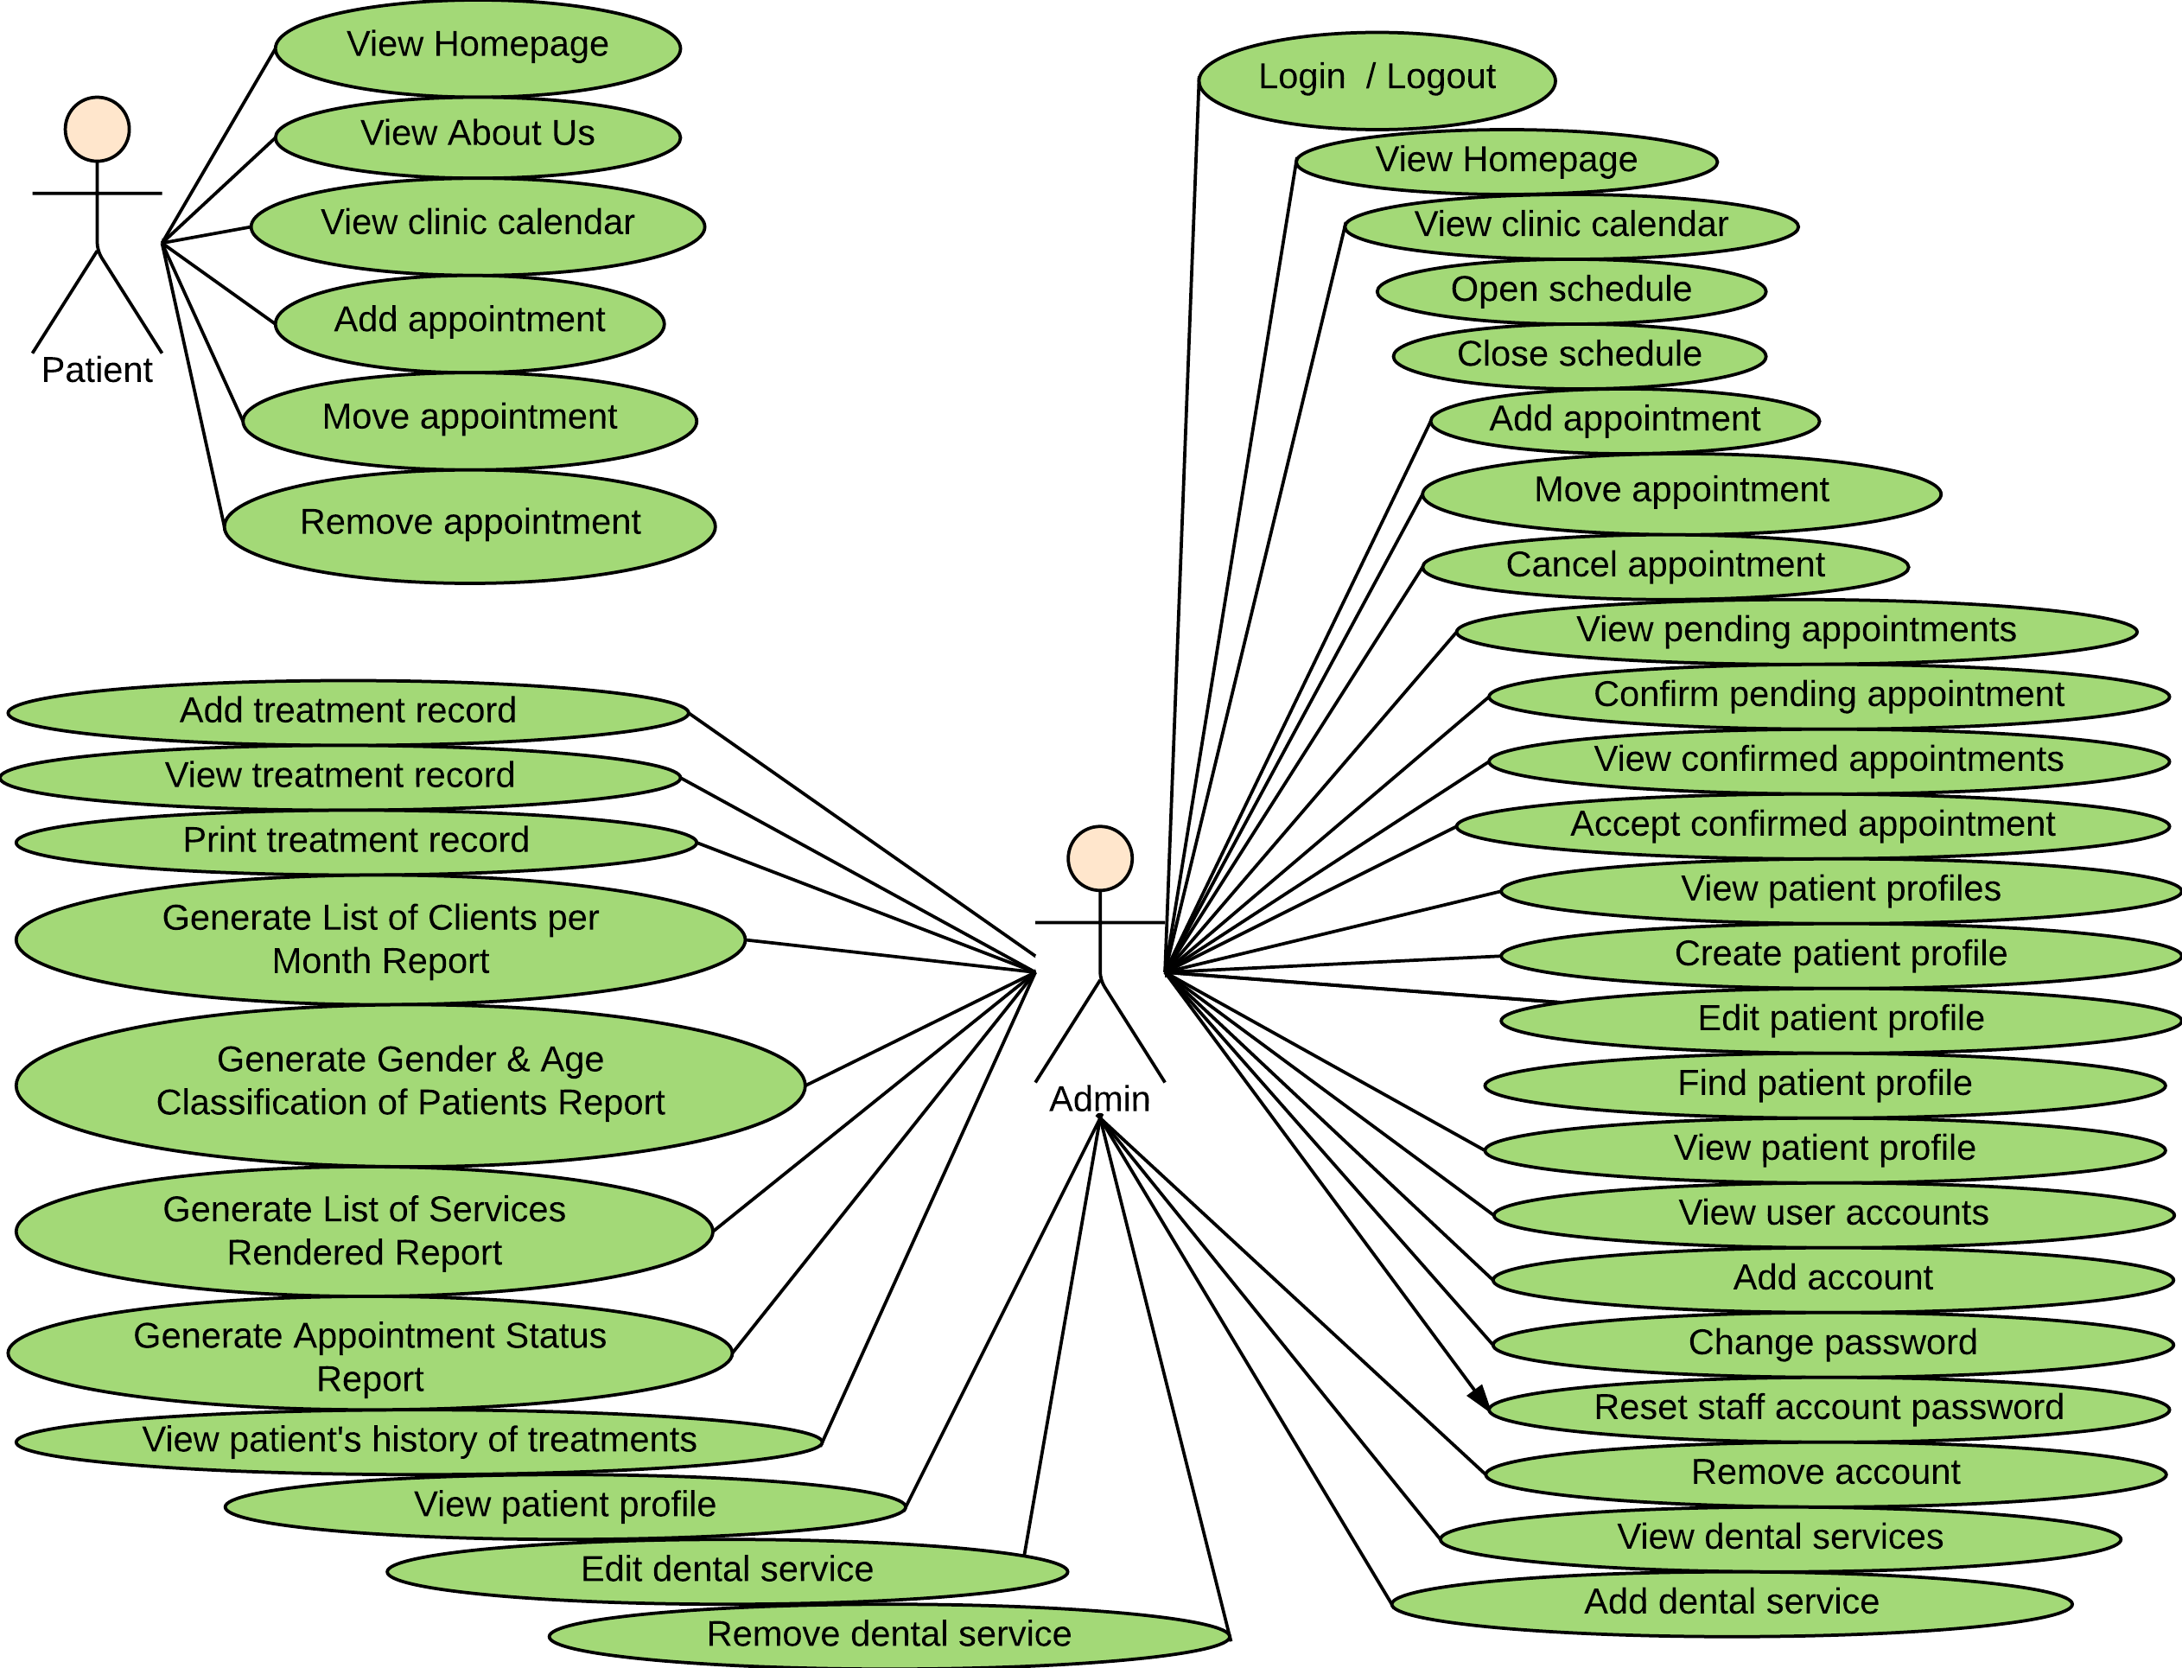**4.2.2 ERD**

**Figure 4.36** shows the ERD of the Gayatin Dental Clinic Online Appointment and Patient Profiling System. The ERD currently contains 14 database tables.

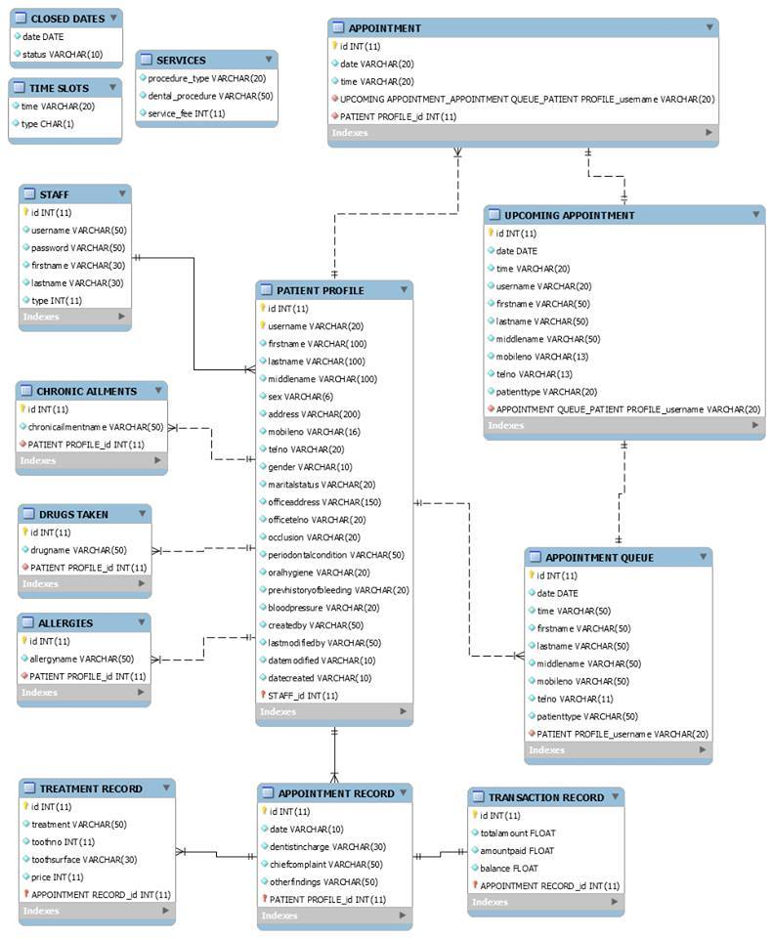

Figure 4.36 ERD

*Figure 4.32 Entity Relationship Diagram*

**4.3 Testing and Evaluation**

Table 4.17 Log in

|  |  |  |  |  |
| --- | --- | --- | --- | --- |
| **User** | **Input** | **Expected result** | **Actual Result** | **Status** |
| 1.Empty fields | *blank fields | Please fill out the fields | passed | passed |
| 2. Input Username | Username | Log in success | passed | passed |
| Username(Incorrect) | Invalid username or password | passed | passed |
| 3. Input password | Password | Log in success | passed | passed |
| Password(Incorrect) | Invalid username or password | passed | passed |

Table 4.18 Create New Patient Profile

|  |  |  |  |  |
| --- | --- | --- | --- | --- |
| **User** | **Input** | **Expected result** | **Actual Result** | **Status** |
| 1.Empty fields | *blank fields | Please fill out the (name of field) field | passed | passed |
| 2. User name | User name text | Success | passed | passed |
|  | User name text already exist | Username already exists | passed | passed |
| 3. First name | Text | Success | passed | passed |
|  |  |  |  |
| 4. Last name | Text | Success | passed | passed |
| 5. Middle name | Text | Success | passed | passed |
| 6. Home address | Home address | Success | passed | passed |
| 7.Tele phone number | Telephone number | Success | passed | passed |
| Wrong format | Please match the requested format | passed | passed |
| 8.Mobile number | Mobile number | Success | passed | passed |
| Wrong format | Please match the requested format | passed | passed |
| 9.Gender | Gender | Success | passed | passed |
| 10.Marital Status | Marital Status | Success | passed | passed |
| 11.Office Address | Address | Success | passed | passed |
| 12.Work Telephone number | Telephone number | Success | passed | passed |
| Wrong format | Please match the requested format | passed | passed |
| passed | passed |
| 13.Occlusion | Occlusion Drop down | Success | passed | passed |
| 14.Periodontal Condition | Periodontal Condition | Success | passed | passed |
| 15.Oral Hygiene | Oral Hygiene | Success | passed | passed |
| 16.Previous History of Bleeding | Yes or no | Success | passed | passed |
| 17.Blood Pressure | Integer | Success | passed | passed |
| Float | Invalid Input | passed | passed |
| 18.Chronic Ailments | Text | Success | passed | passed |
| 19.Drugs Taken | Text | Success | passed | passed |
| 20.Allergies | Text | Success | passed | passed |

Table 4.19 Create New Staff Account

|  |  |  |  |  |
| --- | --- | --- | --- | --- |
| **User** | **Input** | **Expected result** | **Actual Result** | **Status** |
| 1.Empty fields | *blank fields | Please fill out the (name of field) field | passed | passed |
| 2. First Name | Text | Success | passed | passed |
| 3. Last Name | Text | Success | passed | passed |
| 4. User Name | Text | Success | passed | passed |

Table 4.20 Change Password

|  |  |  |  |  |
| --- | --- | --- | --- | --- |
| **User** | **Input** | **Expected result** | **Actual Result** | **Status** |
| 1.Empty fields | *blank fields | Please fill out the (name of field) field | passed | passed |
| 2. Old Password | Old password text | Success | passed | passed |
| Wrong password | Please input your correct password | passed | passed |
| 3. New Password | New password text | Success | passed | passed |
| 4.Confirm Password | Identical to the new password | Success | passed | passed |
| Password does not match to new password | Password/ Confirmation does not match | passed | passed |

Table 4.21 Edit Patient profile

|  |  |  |  |  |
| --- | --- | --- | --- | --- |
| **User** | **Input** | **Expected result** | **Actual Result** | **Status** |
| 1.Empty fields | *blank fields | Please fill out the (name of field) field | passed | passed |
| 2. First Name | Text | Success | passed | passed |
| 3. Middle Name | Text | Success | passed | passed |
| 4. Home Address | Text | Success | passed | passed |
| 5. Telephone number | Telephone Number | Success | passed | passed |
| Wrong Format | Please match the requested format | passed | passed |
| 6. Mobile number | Mobile Number | Success | passed | passed |
| Wrong Format | Please match the requested format | passed | passed |
| 7. Gender | Gender Drop down | Success | passed | passed |
| 8. Marital Status | Marital Status Drop down | Success | passed | passed |
| 9. Office Address | Office Address(optional) | Success | passed | passed |
| 10.Office Telephone number | Office telephone number(optional) | Success | passed | passed |
| 11.Occlusion | Occlusion Drop down | Success | passed | passed |
| 12.Periodontal Condition | Periodontal Condition Drop down | Success | passed | passed |
| 13. Oral Hygiene | Oral Hygiene Drop down | Success | passed | passed |
| 14. Previous History of Bleeding | Previous History of Bleeding  Drop down | Success | passed | passed |
| 15. Blood Pressure | Blood Pressure | Success | passed | passed |
| 16.Chronic Ailments | Chronic Ailments(optional) | Success | passed | passed |
| 17.Drugs Taken | Drugs Taken(optional) | Success | passed | passed |
| 18.Allergies | Allergies(optional) | Success | passed | passed |

Table 4.22 Add Pending Appointment

|  |  |  |  |  |
| --- | --- | --- | --- | --- |
| **User** | **Input** | **Expected result** | **Actual Result** | **Status** |
| 1.Empty fields | *blank fields | Please fill out the (name of field) field | passed | passed |
| 2. Patient Type | Patient Type | Success | passed | passed |
| 3. Old Patient- Username | Username | Success | passed | passed |
| Username(does not exist) | Username doesn’t exist | passed | passed |
| 4. New Patient-Username | Text | Success | passed | passed |
| 5.Firstname | Text | Success | passed | passed |
| 6. Last name | Text | Success | passed | passed |
| 7. Middle name | Text | Success | passed | passed |
| 8. Mobile number | Mobile number | Success | passed | passed |
| Mobile number (wrong format) | Invalid format | passed | passed |
| 9. Agreement Check Box | Checked | Success | passed | passed |
| Not Checked | Success | passed | passed |